|  |  |
| --- | --- |
| **Stage Discovered** | **Defect Count** |
| Requirements Review | 1 |
| Design Review | 4 |
| Code Review | 6 |
| Case Testing | 17 |
| Tools Testing | 1 |
| Acceptance Testing | 0 |

The total size of the software is 143 FP.

Calculate the DRE and DD for the project and help the management analyze data.

**DRE**

The DRE of the software project is calculated as:

N1 = 1 + 4 + 6 + 17+1 = 29 defects

N2 = 29 defects



Therefore, the DRE = 29/29 = 100%

**DD**

DD is the defect density in a software project. This provides a normalized view of the software. The formula for DD is:

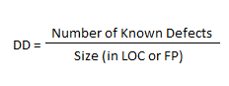

N1 = 1 + 4 + 6 + 17+1 = 29 defects

Therefore, DD = 29/143= 0,2028